Copyright for test papers and marking guides remains with West Australian Test Papers.
The papers may only be reproduced within the purchasing school according to the advertised Conditions of Sale.
Test papers must be withdrawn after use and stored securely in the school until 11th June2021.


PSYCHOLOGY
ATAR YEAR 11
UNIT 1

2021

MARKING GUIDE

Section One: Research Methods 20% (30 marks)
______________________________________________________________________________
Question 1 (11 marks)

Forty participants were tasked with learning a list of 20 words while listening to music. An hour later, the participants were randomly allocated into two equal size groups and their recall ability was assessed when they were asked to recall the list of words. Group one completed their recall while listening to the same music played at the beginning of the study, while Group two recalled the words in silence. The table below shows the results collected.

 | Group one | Group two
Mean | 16 | 10
Range | 8 | 12

a) Comment on the spread of scores for each of the two groups. (1 mark)

Description | Marks
Group one had a lower spread of scores than group two | 1
Total | 1

b) Write a suitable operationalised hypothesis for this study. (4 marks)

Description | Marks
Population mentioned | 1
A predicted direction or difference | 1
Operationalised independent variable: listening to music that was played during learning or not listening to music | 1
Operationalised dependent variable: recall measured by number of words recalled from a list of 20 | 1
Example: It is hypothesised that participants will have better recall (recall more words from a list of 20) when listening to the music that was played during learning than when not listening to music.
Total | 4

c) Outline two benefits of randomly allocating participants into each group. (2 marks)

Description | Marks
Participants have an equal chance of being put into either group | 1
Researcher bias would be reduced | 1
Total | 2
Any relevant reason accepted for one mark

Question 1 (continued)

d) There were two groups, one for each condition of the independent variable. Explain two reasons
why this is an advantage of the study, rather than having all participants exposed to both
conditions (having to recall the words while listening to music and then again without music).
(4 marks)

Description (any two of the below) | Marks
• Participants are less likely to drop out of the study because it is not very time  consuming.  • Participants are likely to stay interested in the study/less likely to become bored  because they only complete the recall of words once.  • In order to eliminate practice effect whereby word recall may improve due to the  repetition of the task. | 1-4
Total | 4
Any relevant explanation accepted for two marks

Question 2 (13 marks)

A personal trainer wanted to investigate whether the tempo of music listened to while walking affected the speed at which people walk. She predicted that the faster the tempo of music listened to, the faster the person would walk. The personal trainer used beats per minute (bpm) as a measure of music tempo and recorded the distance (km) that 20 seventeen-year-old students walked for one hour on a treadmill. Five students were allocated into four different conditions, their results shown in the table below.

Condition | Average distance walked (km)
Condition one: walking without listening to music | 3
Condition two: walking listening to music at 40-70 bpm | 2.5
Condition three: walking listening to music at 85-110 bpm | 4
Condition four: walking listening to music at 120-140 bpm | 5.5

a) Graph the results from the above information into the grid below. (5 marks)
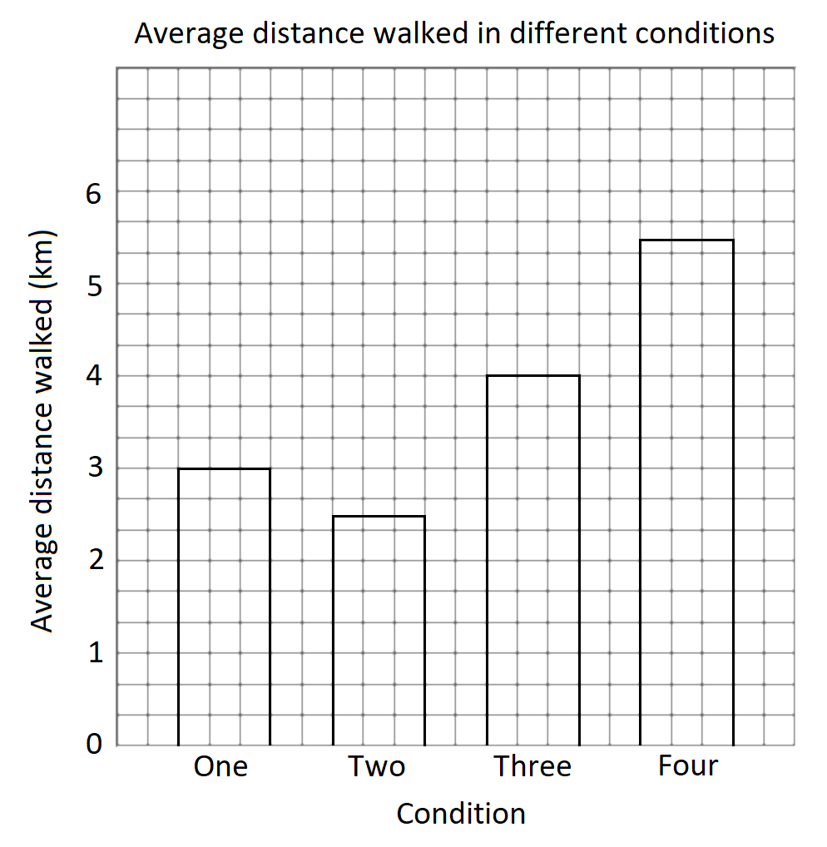

Description | Marks
Bar graph is drawn | 1
Title includes both variables | 1
X and Y-axis have correct headings with appropriate units of measurement | 1
Both axis have appropriate scales | 1
Bars are drawn to correct heights | 1
Total | 5

Question 2 (continued)

b) A statistical test found that the difference between condition 3 and 4 was statistically
significant. Explain what this means. (2 marks)

Description | Marks
The probability that the results were due to chance/not due to the independent  variable | 1
Is less than 5% | 1
Total | 2
Also accept: the probability that the results were due to the independent variable and not due to chance was more than 95%

c) Outline two ways that the reliability of the experiment could be increased. (2 marks)

Description (any two of the below) | Marks
• Have each participant complete multiple trials  • Run the experiment a second time  • Increase the sample size | 1
Total | 2

d) Identify two ethical considerations related to this experiment and explain why the personal
trainer should take them into consideration. (4 marks)

Description (any two of the below) | Marks
• Informed consent: written consent needs to be provided by the legal guardians  of participants as they are under the age of 18.  • Withdrawal rights: participants may want to remove themselves from the study if  they become too tired to walk for the whole hour. | 1-4
Total | 4
Note: one mark for identifying the ethical consideration, one mark for the explanation
Any relevant ethical consideration and explanation accepted for two marks each

Question 3 (6 marks)

Miss Kicisnski had her small group of students sit a 20-mark test after no revision and then another test after allowing them two hours of revision. Their test results are shown in the table below.

Participant | Score on test without revision | Score on test after 2 hours of revision
1 | 11 | 15
2 | 6 | 17
3 | 8 | 20
4 | 10 | 14
5 | 7 | 12

a) i. Calculate the mean score for participants who did no revision before their test, giving the
answer correct to one decimal place. (1 mark)

Description | Marks
8.4 | 1
Total | 1

ii. Calculate the median score for participants who did 2 hours of revision before their test.
(1 mark)

Description | Marks
15 | 1
Total | 1

b) State whether Miss Kicinski’s research is experimental or non-experimental and provide one
reason for your response. (2 marks)

Description | Marks
Experimental | 1
Any one of the below  • The independent variable has been manipulated  • There is a cause-and-effect relationship | 1
Total | 2

c) The data collected for the research was quantitative.

i. Provide one benefit of collecting quantitative data. (1 mark)

Description (any one of the below) | Marks
• It is less time consuming to collect data compared to qualitative research  • It is less time consuming to collate data compared to qualitative research  • It is less time consuming to analyse data compared to qualitative research  • Results can be generalised to the population the sample was taken from  • Results can be statistically analysed  • It costs relatively less to run than qualitative research | 1
Total | 1

Question 3 (continued)

ii. Provide one benefit of collecting qualitative data. (1 mark)

Description (any one of the below) | Marks
• It provides detailed information  • It allows for individuals to explain the reasons behind their responses  • It allows for flexibility as researchers can adapt questions as needed | 1
Total | 1

End of Section One
Section Two: Short Answer 55% (96 marks)
______________________________________________________________________________
Question 4 (17 marks)

In the Netflix drama, The Queen’s Gambit, the main character is Beth, a chess prodigy who strives to become the greatest chess player in the world. The game of chess requires skills that are dominantly controlled by the left or right cerebral hemispheres in the brain.

a) For the following examples, identify whether the left or right hemisphere is more dominant.

i. Recognising that the chess board has a pattern of dark and light squares. (1 mark)

Description | Marks
Right hemisphere | 1
Total | 1

ii. The abstract reasoning required when working out which piece to move (if I move my rook
here, then I can take out his bishop). (1 mark)

Description | Marks
Left hemisphere | 1
Total | 1

iii. Visualising in your mind a combination of moves to make on the board. (1 mark)

Description | Marks
Right hemisphere | 1
Total | 1

iv. Moving a chess piece with your left hand. (1 mark)

Description | Marks
Right hemisphere | 1
Total | 1

b) Describe the location of the cerebral cortex in the brain. (2 marks)

Description | Marks
The outer layer/external layer | 1
Of the cerebral hemispheres/of the brain closest to the skull | 1
Total | 2

c) Describe the physical structure of the corpus callosum. (1 mark)

Description | Marks
Thick band of nerve fibres | 1
Total | 1

Question 4 (continued)

d) i. Using the diagram below, identify the part of Phineas Gage’s brain that sustained most of
the damage during his accident (shade in or draw a line around the part). (1 mark)
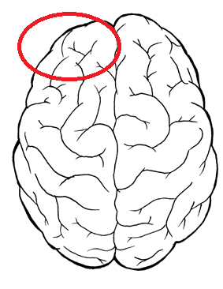

Description | Marks
Left frontal lobe is identified on diagram | 1
Total | 1

ii. Name the research method used to study one person, such as Phineas Gage, or a small
group of people. (1 mark)

Description | Marks
Case study | 1
Total | 1

e) Describe the path messages take when travelling through a sending (presynaptic) neuron to a
receiving (post synaptic) neuron. (4 marks)
Description | Marks
Message moves from the dendrites to the cell body | 1
From the cell body down the axon to the axon terminals | 1
From the axon terminal through the synapse | 1
From the synapse to a dendrite of the receiving neuron | 1
Total | 4
Note: sequence can start at any point but must flow in given order

f) i. Explain how fast-growing tissues in the brain, such as cancerous tumours, are detected by
the positron emission tomography scan (PET). (2 marks)

Description | Marks
Fast growing/fast metabolising cells use glucose quickly | 1
PET scans involve the use of a tracer that shows areas where glucose is used up | 1
Total | 2

ii. Outline two differences between an MRI scan and fMRI scan. (2 marks)

Description (any two of the following) | Marks
• fMRI scans take dynamic pictures whereas MRI scans take still pictures.  • fMRI scans do not require the use of a tracer whereas MRI scans can require  use of a tracer.  • More is understood about how MRI scans work than how fMRI scans work. | 1-2
Total | 2
Any relevant difference accepted for one mark
Question 5 (14 marks)

a) Explain two ways in which exercise can affect emotion (4 marks)

Description | Marks
Examples of correct answers include:  • Exercise increases the release of mood-boosting neurotransmitters/serotonin/  endorphins. These neurotransmitters can improve mood/reduce symptoms of  depression.  • Cortisol is a hormone that increases stress.  Exercise reduces cortisol in the blood which reduces stress.  • Exercise can produce a ‘runner’s high.  It produces feelings of euphoria and happiness. | 1  1  1  1  1  1
Total | 4
Any relevant explanation accepted for two marks. One mark for identifying the function that exercise performs, one mark for the emotion that is changed/felt.

b) i. Comment on the effect that recreational drugs have on perception. (1 mark)

Description | Marks
Recreational drugs alter/change perception | 1
Total | 1

ii. Name one recreational drug that may cause the effect described in part (i). (1 mark)

Description (any one of the following) | Marks
• Marijuana.  • LSD.  • Ecstasy.  • Magic mushrooms (psylocibin). | 1
Total | 1
Any relevant difference accepted for one mark

c) Complete the table below. (8 marks)

 | Amphetamine | Alcohol
Class of drug | Stimulant | Depressant
Effect on central nervous system | Speeds up/increases activity | Slows/decreases activity
Effect on breathing rate | Increases breathing rate | Decreases breathing rate
Effect on confidence levels | Increases confidence levels | Increases confidence levels

Question 6 (16 marks)

When viewing stimuli, part of the image projected onto the retina of the eye is obstructed by the spot at which the optical nerve joins the retina. This spot is known as the ‘blind spot’.

a) Name the process that allows the brain to fill in the gap formed by the blind spot and form a
whole coherent image. (1 mark)

Description | Marks
Perception | 1
Total | 1

b) Outline one reason why psychologists study illusions. (1 mark)

Description | Marks
Studying illusions lets psychologists better understand the process of perception. | 1
Total | 1

c) Is the image below shifting between a rabbit and duck due to it being a visual illusion, or is it due
to a shift in attention? Explain your response. (3 marks)
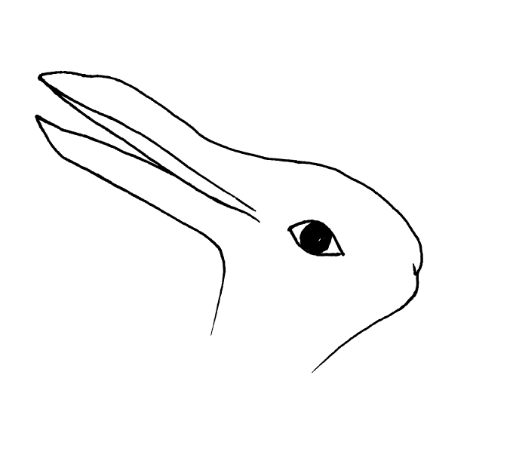

Description | Marks
Due to a shift in attention | 1
If the image is looked at from the left to the right a duck is seen whereas a rabbit is seen if the image is looked at from right to left / the image can be perceived in two different ways depending on which part of the image the eyes focus on first | 1
It is not a visual illusion because no features of the stimulus are being misjudged (length, motion, position, curvature, direction) | 1
Total | 3

d) i. List the two main categories of consciousness. (2 marks)

Description | Marks
Normal waking consciousness | 1
Altered states of consciousness | 1
Total | 2

Question 6 (continued)

ii. State one example of an altered state of consciousness that occurs naturally and one
example of an altered state of consciousness that can be induced. (2 marks)

Description | Marks
Naturally occurring: sleep, daydreaming, coma | 1
Induced: hypnosis, anaesthetised, alcohol-induced state, meditation, medically induced coma | 1
Total | 2

e) i. A nurse is wanting to check whether a patient has been anaesthetised and is ready for
surgery. Name one physiological measure the nurse could use in order to determine the
state of consciousness of the patient. (1 mark)

Description (any one of the below) | Marks
• Heart rate.  • Body temperature.  • Electrical activity of the brain.  • Galvanic skin response. | 1
Total | 1

ii. Outline the reading likely to be shown by the physiological measure named in part (i) if the
patient has in fact been anaesthetised. (1 mark)

Description | Marks
• Heart rate: slightly faster than the normal range/slightly slower than the normal  range  • Body temperature: around 36°C / temperature decreases by around 1 degrees  • Electrical activity of the brain: low frequency  • Galvanic skin response: low galvanic skin response | 1
Total | 1

f) There are certain recreational drugs that can cause the user to enter a drug-induced state of
consciousness where the heart rate increases above normal levels. Identify one such drug.
(1 mark)

Description (any one of the below) | Marks
• Amphetamine.  • Caffeine.  • Nicotine.  • Cocaine.  • Crystal methamphetamine (ice, crystal meth). | 1
Total | 1
Any relevant drug accepted for one mark

Question 6 (continued)

g) A researcher investigating attention set up a number of trials using a mouse placed inside a
cage with one side made of clear perspex allowing for the mouse to be observed.

i. Through a small speaker in the cage, a large ‘bang’ was sounded and the mouse jumped in
shock. Describe the behaviour of the mouse after the banging noise was sounded 5 or 6
times over a minute. (1 mark)

Description | Marks
The mouse stopped jumping/had no reaction to the banging sound | 1
Total | 1

ii. Name the process that is described in part (i). (1 mark)

Description | Marks
Habituation | 1
Total | 1

iii. A few minutes later a new sound, a shrill ‘ding’ noise, is made. Describe the behaviour that
the researcher would likely observe in the mouse. (1 mark)

Description | Marks
The mouse jumps in fright | 1
Total | 1

iv. Name the process that is described in part (iii). (1 mark)

Description | Marks
Dishabituation | 1
Total | 1

Question 7 (18 marks)

a) A psychologist is providing therapy to a new client, Chris, who was encouraged by his girlfriend
to attend, but who is not particularly open to the experience.

i. As the psychologist asks Chris questions, he is not replying to her in detail, however, he
is making gestures as he speaks. Explain how Chris’ gestures can help the psychologist
provide him with beneficial therapy. (2 marks)

Description | Marks
The gestures he makes can reflect his unspoken thoughts/feelings. | 1
His gestures may help the psychologist better understand him/his needs. | 1
Total | 2

ii. There are many examples of gestures that humans use when communicating, whether or
not they are aware they are making them. List three examples of gestures. (3 marks)

Description (any three of the below) | Marks
• Nodding of the head.  • Tilting the head to one side.  • Leaning in to listen to someone.  • Making a thumbs up sign.  • Pointing with a finger.  • Stroking the beard or chin with fingers.  • Using fingers to list. | 1-3
Total | 3
Any relevant response accepted for one mark

b) There are some facial expressions that can help humans to survive. When showing fear, pupils
dilate and the mouth is open. Explain how dilated pupils and an open mouth would improve the
survival rate of a human in danger. (4 marks)

Description | Marks
Dilated pupils allow for more light to enter the eyes.  More light allows for better vision. | 1  1
An open mouth allows for more oxygen to enter the lungs.  Muscles require oxygen for movement. | 1  1
Total | 4

c) Explain why sign language, such as Auslan, is not considered ‘body language’. (2 marks)

Description | Marks
Sign language is an official language.  Sign language has its own grammar system. | 1-2
Total | 2
Any relevant explanation accepted for two marks

Question 7 (continued)

d) Robinson published a book in 2003 which drew attention to the different ways adults
communicate socially.

i. Name the nonverbal social skill addressed by Robinson. (1 mark)

Description | Marks
Shaking hands | 1
Total | 1

ii. According to Robinson, using politeness as a behaviour when communicating requires two
concepts that need to be taken into account. Outline these two concepts. (2 marks)

Description | Marks
Whether or not the desired outcome will be achieved. | 1
Whether or not there is a risk of being humiliated. | 1
Total | 2

e) Define the term ‘hearing impairment’. (1 mark)

Description | Marks
Hear loss that is either total or partial | 1
Total | 1

f) Annie is 8-years-old and presents with language delays due to having a mild intellectual
disability. Outline three ways that the delay in her language skills would affect her development
in primary school. (3 marks)

Description (any three of the below) | Marks
• Difficulties with communicating with peers.  • Delayed speech development.  • Delayed cognitive skills.  • Decreased writing ability.  • Decreased reading ability. | 1-3
Total | 3
Any relevant response accepted for one mark

Question 8 (17 marks)

a) Explain why it is difficult to define ‘intelligence’. (2 marks)

Description | Marks
It is a hypothetical construct | 1
Intelligence itself cannot be seen, only its effects can be observed | 1
Total | 2

b) The multiple intelligences theory claims that there are numerous intelligences that each person
possesses.

i. Name the theorist who developed this theory. (1 mark)

Description | Marks
Gardner/Howard Gardner | 1
Total | 1

ii. Contrast between intrapersonal intelligence and interpersonal intelligence. (2 marks)

Description | Marks
Intrapersonal intelligence involves the ability to understand the self and own thoughts, feelings and intentions | 1
Interpersonal intelligence involves the ability to understand the thoughts, feelings and intentions of others | 1
Total | 2

iii. Describe how multiple intelligences can be used by primary school teachers in the
classroom. (1 mark)

Description (any one of the below) | Marks
• Activities can be tailored to children to meet their individual needs  • The teacher can tailor activities to build on the strengths of children  • The interests that children have can be used to create successful learning  opportunities | 1
Total | 1
Any relevant response accepted for one mark

c) Below is a diagram used to describe the two-factor theory.
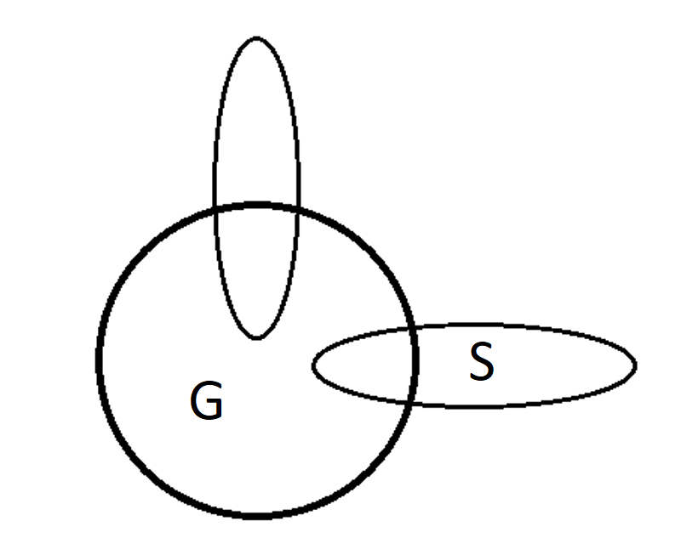

i. Identify what part ‘G’ in the diagram refers to. (1 mark)

Description | Marks
General ability | 1
Total | 1

Question 8 (continued)

ii. Identify what part ‘S’ in the diagram refers to. (1 mark)

Description | Marks
Specific ability | 1
Total | 1

iii. Name the theorist who developed the two-factor theory of intelligence. (1 mark)

Description | Marks
Spearman | 1
Total | 1

iv. The theorist named in part (iii) administered a range of tests on children and found scores
on tests, such as maths and logical reasoning, had strong positive correlations with each
other. Explain what this means. (2 marks)

Description | Marks
If a child received a high score in one test/maths test  They would also receive a high score in another test/logical reasoning test | 1  1
Total | 2
Also accept: receiving a low score on one test is related to receiving a low score on another test

d) i. Name the model of intelligence developed by Wechsler. (1 mark)

Description | Marks
Empirical | 1
Total | 1

ii. Wechsler produced tests for both children and adults that formed a score. Name the
score that was produced. (1 mark)

Description | Marks
IQ/intelligence quotient | 1
Total | 1

e) Individual intelligence testing requires the examiner to build rapport with the test taker. Outline
how this may be a benefit of individual intelligence testing as well as be seen as a limitation.
(2 marks)

Description | Marks
Advantage  • The test taker will feel more at ease during the test. | 1
Limitation  • The test will take longer overall as it takes time for the examiner to build a  positive relationship with the test taker. | 1
Total | 2
Any relevant benefit for one mark and any relevant limitation for one mark

Question 8 (continued)

f) Explain why scores are generally dependent on reading ability in group intelligence tests,
while in individual intelligence tests, scores are not generally dependent on reading ability.
(2 marks)

Description | Marks
Group intelligence tests are typically pencil and paper tests that require test takers to read the questions to themselves individually | 1
An examiner reads questions to the test taker in individual intelligence tests so reading ability is not critical | 1
Total | 2

Question 9 (14 marks)

a) Popular Australian research on the formation of adolescent groups suggests that peer groups
change over time and move through a number of distinct stages.

i. Identify the number of stages theorised in the research. (1 mark)

Description | Marks
Five | 1
Total | 1

ii. At which stage does group membership require a degree of conformity among members?
(1 mark)

Description | Marks
Stage one | 1
Total | 1

iii. Which stage is made up of numerous couples that spend time together? (1 mark)

Description | Marks
Stage four | 1
Total | 1

iv. During which stage does dating between adolescents occur? (1 mark)

Description | Marks
Stage three | 1
Total | 1

b) Provide two reasons why bullying is a form of anti-social behaviour. (2 marks)
Description (any two of the following) | Marks
• Bullying is intentional behaviour  • Bullying causes harm to another person  • Bullying is viewed negatively by society | 1-2
Total | 2
Any relevant reason accepted for one mark

c) Outline two characteristics of pro-social behaviour. (2 marks)

Description (any two of the following) | Marks
• No personal reward is sought after  • It involves helping another person  • It is viewed positively by society | 1-2
Total | 2
Any relevant characteristic accepted for one mark

Question 9 (continued)

d) Empathy is one aspect of pro-social behaviour that is believed to be a motivation for people to
help others.

i. Using an example, describe the term ‘empathy’ and explain how it could lead
someone to want to help another person. (3 marks)

Description | Marks
Empathy refers to the ability to feel the emotions that someone else is feeling | 1
For example, seeing someone looking upset when dropping their bag of groceries may lead you to feel distressed also | 1
This could motivate you to help them pick up their groceries of the floor | 1
Total | 3
Any relevant example and explanation accepted for two marks

ii. Vincent is 3-months-old and cries when he requires his needs to be met. Explain why his
survival is partially dependent on his primary caregiver having the ability to feel empathy.
(3 marks)

Description | Marks
Empathy allows for Vincent’s primary caregiver to feel sad/upset when Vincent feels sad/upset | 1
Empathy motivates Vincent’s primary caregiver to satisfy Vincent’s needs so that he is no longer distressed | 1
If Vincent’s primary caregiver did not have empathy, they may not be as sensitive to Vincent’s needs | 1
Total | 3

End of Section Two
Section Three: Extended Answer 25% (52 marks)
______________________________________________________________________________
Question 10 (26 marks)

Year 12 students, Christine and Adelle, met at the Pulse Perspectives exhibition of year 12 art work at the Art Gallery of WA. They started chatting after Adelle complimented Christine on the dress she was wearing and after a few hours discussing the exhibited art together, they exchanged numbers and agreed to meet for coffee the following week. As Christine had her licence and Adelle only lived 10 minutes away, she gave Christine a lift to the café and in return, Adelle paid for Christine’s coffee and cake at the café. Over time, they became close friends.

In your answer you should:

• Define the term ‘liking’.
• Name and outline the three determinants of liking.
• Provide an example of how each determinant of liking can be seen between Christine and Adelle.
• Comment on the type of behaviour demonstrated by both Christine and Adelle.
• Name the researcher that is commonly associated with studying adolescent peer group structure.
• List and outline the three levels of peer groups in adolescence and identify the level that relates
to Christine and Adelle.
• Refer to psychological evidence and understandings.

Guide to marking extended answers | Marks
Definition of liking | 1
Feeling fondness for someone. | 1
Elements of liking | 9
Proximity. Being in close physical distance with another person. Relate to scenario: Christine and Adelle live only 10 minutes from each other.  Similarity. Sharing commonalities with another person. Relate to scenario: Christine and Adelle both have an interest in art/both have a similar fashion sense/both like coffee.  Reciprocity. A person doing something helpful for another person in return for the help they received from them. Relate to scenario: Christine picks up Adelle and drives her to the café and in return Adelle buys Christine coffee and cake. | 1 1 1  1 1 1  1 1 1  1
Type of behaviour | 1
Pro-social | 1
Formation of adolescent groups | 1
Researcher: Dunphy/Dexter Dunphy. | 1
Peer groups | 7
Dyad. Two people who are in an intimate relationship or are close friends. Clique. A small group of people who spend time together often. Crowd. A large group of people who have affiliations or interests in common. Christine and Adelle are in a dyad. | 1 1 1 1 1 1 1
Use of psychological evidence | 4
Two or more statements are supported with a description of relevant evidence using three or more sentences. | 4
Two or more statements are provided with a brief description of relevant evidence using less than three sentences. | 3
One or two statements are supported with reference to relevant evidence. | 1-2
Examples of psychological evidence
• Dunphy’s theory of adolescent peer group structure: in the 1960s Dunphy spent time observing adolescent groups and developed five stages of adolescent group formation. Stage one involved cliques, often made up of the same sex. During stage two, the same-sex cliques interacted with each other, forming a crowd. Stage three saw dating begin between higher-ranking group members. Finally, during stage five couples started to leave the crowd and the crowd disintegrated. • Factors linked to physical closeness: familiarity between people leading to a feeling of comfort. Individuals being available or accessible to each other allowing for further development of their relationship. The expectation both people in a relationship have that they will continue to socially interact.
Quality of extended response | 3
Well-developed sentences and paragraphs and consistent use of appropriate psychological language and correct spelling, grammar and punctuation. | 3
Coherent response with adequate spelling, grammar, sentence structure and paragraph structure. | 2
Single paragraph response or lack of paragraph structure and/or poor sentence structure and/or very colloquial language and/or poor English expression and/or many spelling errors. | 0-1
Total | 26

Question 11 (26 marks)

In the 1960s, Paul Ekman visited people from different cultures and took photographs of their expressions given when presented with scenarios. He then asked participants from around the world to identify the emotions shown in the photographs and discovered that more than 90% of expressions were recognised around the world. Ekman theorised six common facial expressions that are recognised universally.

The ability to recognise facial expressions allows for the emotions of people around us to be identified. Emotional intelligence (EQ) became popularised in the late 1990s and many believe it is as important as IQ for social, academic and professional success.

In your answer you should:

• Name the type of communication facial expressions are categorised under.
• Define the term ‘facial expression’.
• List four common facial expressions that are universally recognised.
• Name the theorist who popularised EQ theory in the late 1990s.
• Outline the three main concepts that make up EQ.
• Suggest two reasons why many people believe EQ is a valuable skill that leads to success in the
workplace.
• Define the term ‘active listening’ and, considering an individual with high EQ, provide two examples
to show how they could actively listen to another person.
• Refer to psychological evidence and understandings.

Guide to marking extended answers | Marks
Type of communication | 1
Non-verbal communication. | 1
Definition of facial expression | 1
Muscle movement under the skin of the face. | 1
Universally recognised facial expressions (any four of the following) | 4
Anger. Surprise. Fear. Sadness. Happiness. Disgust. | 1-4
Emotional intelligence theory | 4
Popularised by Daniel Goleman/Goleman.  Emotional intelligence refers to the ability to recognise emotions we are feeling, regulate our own emotions and recognise the emotions of others. | 1  1 1 1
Reasons employers hire people with high EQ | 4
People with high EQ are able to recognise the emotions of others therefore are more likely to work successfully in a team. People with high EQ are able to regulate their own emotions meaning they can stay calmer in stressful work environments. Any relevant explanation for two marks | 1-2  1-2
Active listening | 5
Definition: engaging in a conversation while trying to empathise with what the person is saying.  A gentle touch on the arm or shoulder shows that the listener is physically and emotionally available to genuinely listen to what the speaker is saying.  Before responding to the speaker, the listener pays attention to nonverbal cues to work out how the speaker is feeling.  Any relevant example for two marks each | 1  1-2  1-2
Use of psychological evidence | 4
Two or more statements are supported with a description of relevant evidence using three or more sentences. | 4
Two or more statements are provided with a brief description of relevant evidence using less than three sentences. | 3
One or two statements are supported with reference to relevant evidence. | 1-2
Examples of psychological evidence
• An explanation of how gestures, eye contact, touch, the use of space or body posture could be used in combination with emotional intelligence to more successfully communicate and interact with colleagues in the work environment. • Robinson’s social skills applied to the work environment and how they could be used in combination with emotional intelligence. • Support for Goleman’s emotional intelligence theory: EQ encourages leadership in the workplace and is a type of intelligence sought after by many businesses. • Criticism of Goleman’s emotional intelligence theory: according to Eysenck (2000), Goleman’s theory lacks statistical evidence.
Quality of extended response | 3
Well-developed sentences and paragraphs and consistent use of appropriate psychological language and correct spelling, grammar and punctuation. | 3
Coherent response with adequate spelling, grammar, sentence structure and paragraph structure. | 2
Single paragraph response or lack of paragraph structure and/or poor sentence structure and/or very colloquial language and/or poor English expression and/or many spelling errors. | 0-1
Total | 26

